Chapter 1 Notes
1.1
- Earth’s atmosphere supports life
  - The atmosphere makes life on Earth possible
    - Atmosphere – a whole layer of air that surrounds Earth
      - Keep Earth warm and transports energy
  - Characteristics of the Atmosphere
    - Altitude – distance above sea level
      - As altitude increases, air becomes thinner (Less Dense)
    - Density – the amount of mass in a given volume
- Gases of the Atmosphere
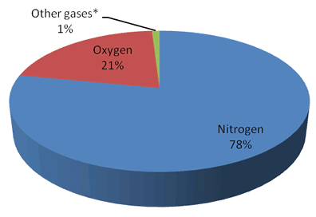
- Natural processes modify the atmosphere
  - The Carbon Cycle
  - The Nitrogen Cycle
  - The Water Cycle
1.2
- The sun supplies the atmosphere’s energy
  - Energy from the sun heats the atmosphere
    - Radiation – energy that travels across distances in the form of certain types of waves
  - Atmosphere moves energy in 3 ways
    - Radiation
    - Conduction – the transfer of heat energy from one substance to another by direct contact
    - Convection – the transfer of energy from place to place by the motion of gas or liquid
  - The atmosphere has temperature layers
    - Troposphere
    - Stratosphere
    - Mesosphere
    - Thermosphere
1.3
- Gases in the atmosphere absorb radiation
  - Gases can both absorb and give off radiation
    - Ultraviolet radiation – (UV) these waves have more energy than the light you can see. Can cause sunburn
    - Infrared radiation – these waves have less energy than visible light, causes materials to warm
  - The greenhouse effect keeps Earth warm
    - Greenhouse effect – is a process where gases in the atmosphere absorb and emit infrared radiation, keeping energy in Earth’s system
    - Greenhouse gases – carbon dioxide, methane, water vapor, nitrous oxide, and other gases that absorb and give off infrared radiation
1.4
- Human activities affect the atmosphere
  - Human activity can cause air pollution
    - Air pollution – smoke and other harmful materials added to the air
  - Types of pollution
    - Particulates – tiny particles or droplets that are mixed in with air
    - Fossil fuels – fuels formed from the remains of prehistoric animals and plants (gasoline, coal, oil)
    - Smog – combination of smoke and fog
  - Effects of pollution
    - Health problems
    - Environmental damage
  - Controlling pollution
    - Make car exhaust cleaner
    - Reduce number of cars on the road
    - Limit amount of pollution from factories and power plants
- Human activities are increasing greenhouse gases
- Human activities produce chemicals that destroy the ozone layer

