Interactive Periodic Table Assignment

Your job is to investigate the periodic table of elements using the interactive periodic table from http://www.ptable.com/ Please make sure that when you are answering the following questions that you are using your own words and not copying directly from the site. You may work with your group during this investigation.

- Find and write down some interesting information about the properties of two groups of elements. In order to do this, click on the properties tab at the top, decide which groups of elements look interesting to you, then click on the group number above the column. Fill out your notes in the table below. (if Wikipedia is blocked you will need to search the web and use different sites… sorry I don’t control what’s blocked)
Group # ____________ | Group #__________________

- Click on the orbitals tab up at the top. What are some interesting things you notice about the orbitals of the elements? Think about how the elements are grouped in the periodic table. Think about what you notice about the energy states of the electrons as the orbitals are being filled. Take some notes in the space below.

- Draw the pictures of the orbitals for Vanadium, and Aluminum in the space below. Please be sure to label which drawing belongs to each element.

- Identify the physical state (solid, liquid, gas) of the following elements
  - Neon: ______________________
  - Cadmium: ______________________
  - Mercury: ______________________
  - Radium: _______________________
- Now change the temperature of the elements to a degree of your choosing (use the scroll bar in the upper right hand portion of the periodic table) Record the temperature that you chose below (don’t forget your units) and identify the new physical states of the same elements as in question 4.
  - Temperature: _____________
  - Neon: ______________________
  - Cadmium: ______________________
  - Mercury: ______________________
  - Radium: _______________________
- Write down what is meant by the following terms…. (Use your books if you need to since Wikipedia is blocked)
  - Metalloid:

  - Nonmetal:

  - Metal:

- Write out the unabbreviated electron configuration for the elements listed below
  - Ruthenium

  - Argon

  - Radon

  - Phosphorus

  - Cesium

- Now write the abbreviated electron configuration for these elements
  - Ruthenium

  - Argon

  - Radon

  - Phosphorus

  - Cesium

- Fill out the following electron box diagram for the element Aluminum. 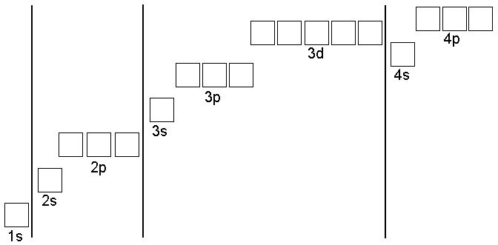

- Fill out the following electron box diagram for the element Gallium.
Element | # of Protons | # of Electrons
Polonium
Seaborgium
Fermium
Lutetium
Neodymium

- Identify the number of protons and electrons in the atoms of the following elements.

- Complete the following chart for the elements

