Metric System Notes
Length
- The basic unit of length in the metric system is the meter and is represented by a lowercase m.
- Standard: The distance traveled by light in absolute vacuum in 1⁄299,792,458 of a second.

Mass
- Mass refers to the amount of matter in an object.
- The base unit of mass in the metric system in the gram and is represented by g.
- Standard: 1 kilogram is equal to the mass of the International Prototype Kilogram (IPK), a platinum-iridium cylinder kept by the BIPM at Sèvres, France.
How to use a Triple Beam Balance:
- Place the item on the scale
- Slide the large weight to the right until the arm drops below the line. Move the rider back one groove. Make sure it “locks” into place.
- Repeat this process with the top weight. When the arm moves below the line, back it up one groove.
- Slide the small weight on the front beam until the lines match up.
- Add the amounts on each beam to find the total mass to the nearest tenth of a gram.
Volume
- Volume is the amount of space an object takes up.
- The base unit of volume in the metric system in the liter and is represented by L or l.
- Standard: 1 liter is equal to one cubic decimeter
- We will be using graduated cylinders to find the volume of liquids and other objects.
- Read the measurement based on the bottom of the meniscus or curve. When using a real cylinder, make sure you are eye-level with the level of the water.
- We can measure the volume of regular object using the formula length x width x height.
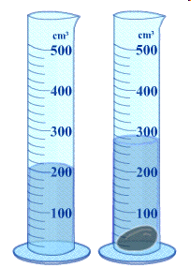
- We can measure the volume of
irregular object using water displacement.
http://resources.edb.gov.hk/~s1sci/R_S1Science/sp/en/syllabus/unit14/new/testingmain1.htm

10 cm
9 cm
8 cm

