Metric System Unit Outline:

- Pretest
  - Assess your knowledge to see what we need to cover in detail
- Length - meter
- Mass - gram
- Volume – liter
- Surface area
- Conversions (English <-> Metric)
- Ladder method
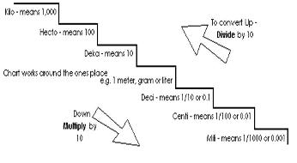

Objectives

- I will be able to measure length of any object using metric units.
- I will be able to mass objects using metric units and the appropriate scale.
- I will be able to determine volume using metric units.
- I will be able to determine surface area.
- I will be able to convert English units to Metric units, and vice versa.
- I will be able to know the prefixes and their meanings used within the Metric system
- I will be able to use the stair-step method to determine the proper units

